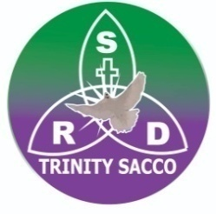
SRD-TRINITY SACCO.
Treasure for the future
P.O.BOX 142 –KASES (U)
Email.srdsacco@gmail.com.
Office line +256-393-245-013 /Tel. 0774071933/ 0784984682

Date of account opening: ……………/………………/……………..
Account created number ……………………………………………………
Key Information Need for opening up a minor / Sunday school account
- Documents Required
  - Minor's birth certificate
  - Proof of identity for the minor, if not the birth certificate, Baptism card
  - Proof of address and identity for the guardian / parent
- Minor's Information:
Full names (As per birth certificate )
Date of birth
Nationality
Minor’s photograph

- Guardian's/ Parents’ Information: (tick appropriately)
Full names
Identity proof (ID, Driving card, Passport )
Photograph of the Guardian/ Parent
Details of the relationship to the minor

- Guardian's Declaration:
I, ……………………………………………………………… the guardian / parent of ……………………
……………………………………………………………………………………………………. confirms that I am the natural or lawful guardian / parent of ……………………………………………………………………………….and will represent the minor in transactions until they reach the age of majority.
- Indemnity Clause:
I …………………………………………………………………. the guardian / parent of ……………………………………………………………declare that, the SACCO shall innocent for any claims made by the minor against transactions conducted by me ……………………………………………. Being the guardian / parent of …….…………
…………………………………………………………………………………………………

- Source of Funds:
Salary
Business
Any other

For official use only
Opened by
Reviewed by
Confirmed

